This is a fantastic **wildlife conservation project** that uses technology to mitigate human-elephant conflicts. Below is an overview of how you can **design and implement** this system.

**Project Overview: Elephant Detection and Deterrent System**

**Objective**

Detect vibrations indicating potential elephant movement, verify presence using a **camera-based AI system**, and trigger deterrent mechanisms like a **buzzer** and **bee sound playback** while notifying authorities via a **GSM module**.

**Hardware Components**

1. **Vibration Sensor** → Detects ground vibrations.
   * Example: **Geophone sensor (SM-24) or MEMS accelerometer (ADXL345)**
2. **ESP32-S3 + ESP32-CAM** → AI-based object detection.
   * **ESP32-CAM** captures images when vibration is detected.
   * **ESP32-S3** runs **YOLOv8** lightweight model for elephant recognition.
3. **Buzzer Module** → Alerts locals when elephants are detected.
4. **Audio Playback Module** → Plays **bee sounds** (Elephants fear bees!).
   * Example: **DFPlayer Mini MP3 module**
5. **GSM Module (SIM800L or SIM7600)** → Sends notifications via SMS or calls.
6. **Power Supply & Backup Battery** → Ensures continuous operation.

**Implementation Steps**

**1. Detect Vibrations**

* The **geophone** or **accelerometer** senses ground vibrations.
* The **ESP32-S3** reads sensor values to determine elephant movement thresholds.
* If a vibration exceeds a predefined threshold → **Trigger camera module.**

**2. Capture and Analyze Image**

* **ESP32-CAM** takes an image when vibration is detected.
* **ESP32-S3 runs YOLOv8** (or TinyML model) to **identify elephants**.
* If an elephant is detected → **Trigger deterrent actions.**

**3. Sound Alarm & Bee Sound Playback**

* **Buzzer** activates to alert people nearby.
* **MP3 Module (DFPlayer Mini)** plays **bee buzzing sounds** to repel elephants.
* Audio plays for a certain period before resetting.

**4. Notify Authorities via GSM**

* If an elephant is detected, **ESP32-S3 sends an alert** via GSM:
  + SMS format:
  + Elephant detected at [Location]. Please take action!
  + Call or alert tones can also be triggered.

**5. System Optimization**

* **Add solar panel power supply** for off-grid use.
* **Deploy multiple nodes** in different locations for a broader monitoring network.
* **Integrate LoRa** for long-range communication instead of GSM in some cases.

## ****Hardware Requirements****

### ****1. Core Processing & AI Unit****

✅ **ESP32-S3-N8R2** – Runs AI-based object detection and system control.  
✅ **ESP32-CAM (OV2640 or OV5640)** – Captures images for YOLO elephant detection.  
✅ **MicroSD Card** – Stores images and logs.

### ****2. Vibration Detection System****

✅ **Geophone Sensor (SM-24) or MEMS Accelerometer (ADXL345)** – Detects ground movement.  
✅ **ADS1115 ADC Module** (if needed) – Converts analog signals for ESP32-S3-N8R2.

### ****3. AI-Based Object Detection****

✅ **TENSORFLOW, YOLOv8-Tiny or MobileNetV2** – Optimized for embedded AI on ESP32-S3-N8R2.

### ****4. Alarm & Deterrent System****

✅ **Buzzer Module (5V or 12V Piezo)** – Sounds alarm.  
✅ **DFPlayer Mini MP3 Module** – Plays **bee buzzing sounds** to deter elephants.  
✅ **Speaker (3W or 5W)** – Amplifies deterrent sounds.

### ****5. Display & User Interface****

✅ **160x80 0.96’ LCD Display (SPI)** – Shows system status, detection alerts, and debug information.

### ****6. Wireless Communication & Alerts****

✅ **SIM800L GSM Module** – Sends SMS alerts.   
✅ **Wi-Fi & MQTT** – Alternative for online data transmission via Blynk.

### ****7. Power Supply & Backup****

✅ **12V Solar Panel + Charge Controller** – Provides off-grid operation.  
✅ **LiFePO4 Battery (12V, 10Ah or higher)** – Ensures continuous power.  
✅ **Buck Converter (5V/3.3V)** – Regulates voltage.

### ****8. Additional Components****

✅ **Relay Module (5V or 12V)** – Controls sirens or external alarms.  
✅ **Weatherproof Enclosure** – Protects components from environmental damage.  
✅ **PCB or Perfboard** – Assembles circuits neatly.

### ****Power Requirements Including ESP32-CAM****

#### **1. 3.3V Buck Converter Power Needs**

| **Component** | **Estimated Current (mA)** |
| --- | --- |
| ESP32-S3-N8R2 | ~250mA (active mode) |
| ADXL345 Accelerometer | ~40mA |
| 160x60 LCD (spi) | ~20mA |
| GSM Module (SIM800L) | ~500mA (during transmission) |
| **Total (Peak)** | **~810mA (~0.8A)** |

#### **1. 4V Buck Converter Power Needs**

| **Component** | **Estimated Current (mA)** |
| --- | --- |
| GSM Module (SIM800L) | ~2A (during transmission) |

**Recommended Buck Converter:**

* **4V, 3A** (to ensure stable operation)

#### **2. 5V Buck Converter Power Needs**

| **Component** | **Estimated Current (mA)** |
| --- | --- |
| ESP32-CAM | ~180mA (idle), ~310mA (flash on) |
| DFPlayer Mini MP3 | ~150mA |
| Speaker (3W) | ~500mA |
| Relay Module | ~100mA |
| **Total (Peak)** | **~1060mA (~1.1A)** |

**Recommended Buck Converter:**

* **5V, 2A** (to handle peak loads)

### ****Key Considerations****

* **ESP32-CAM power consumption varies** depending on whether the flash is on (~310mA) or off (~180mA).
* **Peak GSM transmission** can spike power usage, so a **buffered power supply** is recommended.
* **Ensure stable voltage regulation** to prevent ESP32-CAM resets due to power fluctuations.

Steps to train a **TensorFlow Lite model** for **elephant detection**.

**1. Gather and Label Training Data**

* Collect images of **elephants** and **non-elephant objects**.
* Use **Roboflow** or **LabelImg** to annotate images with bounding boxes.
* Convert data to **TFRecord format** for TensorFlow training.

**2. Train the Object Detection Model**

* Use **TensorFlow Object Detection API** or **TFLite Model Maker**.
* Choose a model like **MobileNet SSD** or **EfficientDet-Lite**.
* Train the model using **Google Colab** or a local machine.
* Youtube model training video https://www.youtube.com/watch?v=yqkISICHH-U

**3. Convert to TensorFlow Lite**

* Optimize the trained model for **embedded devices**.
* Convert it to **TensorFlow Lite (TFLite)** format.
* Apply **quantization** to reduce model size for ESP32-S3.

**4. Deploy on ESP32-S3**

* Load the **TFLite model** onto ESP32-S3.
* Use **TensorFlow Lite Micro** to run inference on captured images.
* Process images locally and classify objects.

**5. Trigger Alerts Based on Detection**

* If an elephant is detected, send an **SMS alert via SIM800L**.
* Update **Blynk** with detection results.
* Activate **buzzer or speaker** to warn nearby areas.

You can follow [this TensorFlow Lite training guide](https://colab.research.google.com/github/EdjeElectronics/TensorFlow-Lite-Object-Detection-on-Android-and-Raspberry-Pi/blob/master/Train_TFLite2_Object_Detction_Model.ipynb) or [this tutorial](https://blog.roboflow.com/how-to-train-a-tensorflow-lite-object-detection-model/) for detailed steps.

ESP32S3 PINOUT

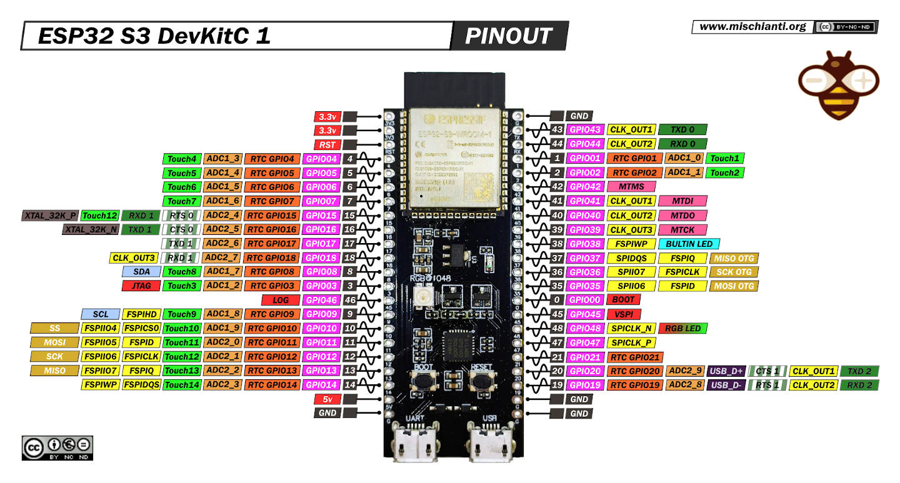

ESP32-CAM PINOUT

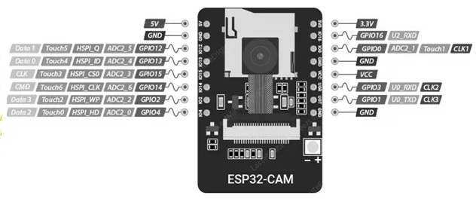

SIM800L PINOUT

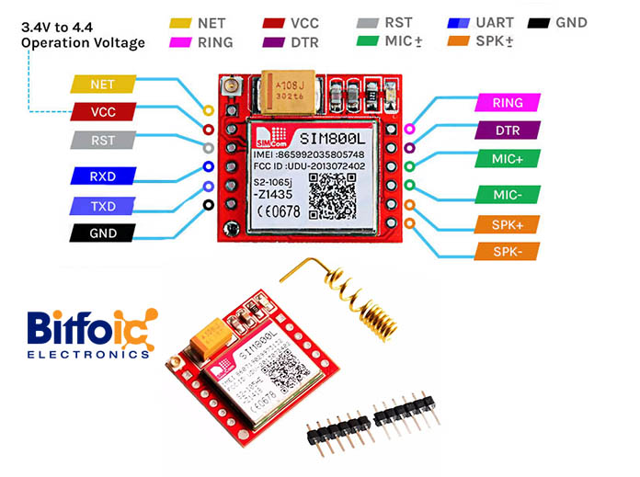

160x80 LCD PINOUT

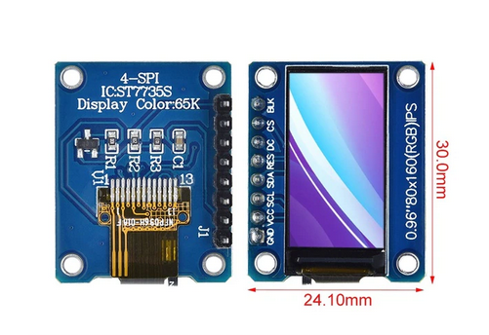

Mp3-tf-16p v3.0 dfplayer

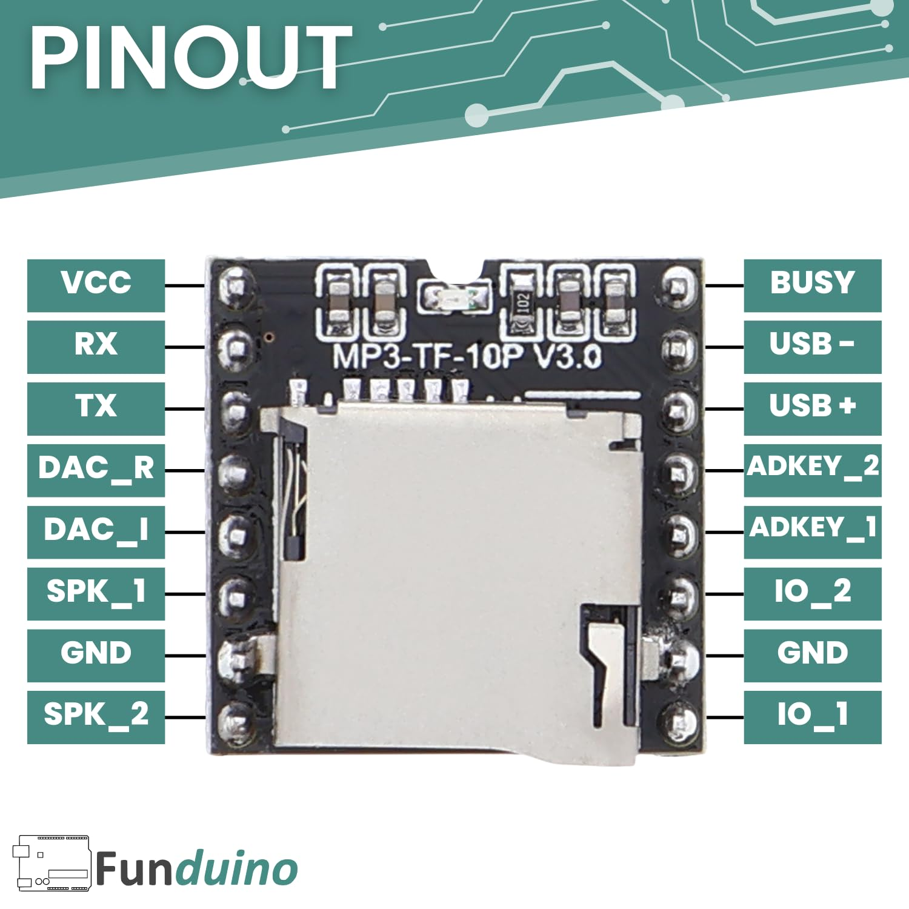

ADXL345 pinout

